ST. JOSEPH COLLEGE OF ARTS AND SCIENCE FOR WOMEN, PAGALPATTI, SALEM

NAAN MUDHALVAN PROJECT

PROJECT WORK REPORT ON
COMICCRAFT – AI COMIC STORY
CREATOR USING GEMINI MODELS

PROJECT DOCUMENTATION

Project Title : ComicCraft – AI Comic Story Creator Using Gemini Models

Team Lead : S.Dharshini

Team Members : S.Arokiya Divya
P.Viji Priya
S.Keerthiga

INTRODUCTION

ComicCraft, also referred to as the AI Comic Story Creator, is an intelligent generative AI assistant and dynamic web application. The project is strategically designed to democratize creative storytelling, allowing non-technical storytellers, writers, and students to instantly transform a conceptual text prompt into structured, panel-by-panel comic scripts. By automating narrative sequencing and descriptive visualizations through cutting-edge large language models, the application provides ready-to-use story boards instantly.

PROJECT OVERVIEW

ComicCraft is built on top of high-performance modern web micro-frameworks integrated with distributed artificial intelligence interfaces. The application provides dynamic routing, responsive templates, operational safety, and absolute persistence across session interactions. The primary goal is to accept abstract user concepts and compile structured panel components consisting of character arcs, localized dialogue structures, environmental details, and scenic visual tags.

Objectives
- Context Preservation: Maintain logical chronological sequencing and character descriptions across multiple narrative comic panels.
- Production Readiness: Supply high-speed API endpoints utilizing lightweight templates for asynchronous message handshakes.
- Extensible Architecture: Build a foundation capable of incorporating graphical diffusion models for visual generation in future iterations.

1.2 Key Features
- Dynamic Routing: Enables seamless navigation and responsive template rendering for user convenience.
- AI Integration: Translates abstract user prompts into structured comic panel components efficiently.

ENVIRONMENT SETUP & PRE-REQUISITES

To execute, debug, and locally orchestrate the system core framework, the environment relies on standard modern baseline specifications.This setup guarantees optimal cross-platform compatibility across various operating systems through structured virtualization layers. Developers must ensure administrative privileges are enabled to allow seamless dependency resolution and package execution.

Hardware Requirements
- Processor: Intel Core i5 / AMD Ryzen 5 or superior core frequencies.
- System Memory: 8 GB Random Access Memory minimum requirement.
- Storage: 500 Megabytes of available non-volatile drive space.

Software Requirements & Toolkits
- Runtime Environment: Python Version 3.9, 3.10, or 3.11 setups.
- Core Application Server: FastAPI Framework managed via Uvicorn server flags.
- Template Engine: Jinja2 Python package for data rendering layers.
- External API Integration: Google Generative AI client toolkit accessing production-ready Gemini models via secure studio developer tokens.

CORE DEVELOPMENT EPICS

Epic 1: Model Selection and Architecture
The development process initiated with the research and selection of specific large language models capable of high-level creative execution. Google Gemini models were selected due to their rich linguistic mastery, dense token window architectures, and structured JSON parsing functionalities. The blueprint employs a modern Model-View-Controller styling layout where the FastAPI layer acts as the centralized system traffic controller, keeping environmental secrets completely isolated from the dynamic HTML visual output view layers.

Epic 2: Core Functionalities Development
This milestone focused on isolating dependency parameters through dedicated virtual python environments to guarantee smooth long-term code maintainability. Developers structured foundational connector pipelines that communicate securely with Google AI Studio. These custom
routines take raw textual user entries and enforce rigid internal schemas to ensure outputs cleanly return panel lists, localized dialogue loops, and rich ambient instructions.

Epic 3: route.py Development
Central application logic and programmatic navigation paths are established within the foundational route.py core module. The engine hosts dedicated HTTP GET request controllers to instantly display responsive portal dashboards to incoming clients. Simultaneously, it configures secure incoming POST payload pathways to grab input fields, filter characters, handle API runtime failure states, and route structured AI data blocks back to active dashboard interfaces.

Epic 4: Frontend Development
The user interface dashboard focuses on responsiveness, speed, and immediate functional clarity. The front-end view layout embeds specialized Jinja2 logical controls directly inside modern structural HTML5 templates. The framework dynamically loops through arrays provided by backend endpoints, generating independent script summaries, panel title segments, dialogue graphics, and scenic labels without relying on dense, heavy client-side scripts.

Epic 5: Testing and Deployment
System verification covers systematic local integration runs utilizing automated server execution instances via standard uvicorn main:app --reload operations. Continuous verification processes ensured complete functional stability during text transformations. Code environments were sanitized by moving keys to local environment configurations, cleaning unused distribution libraries, and pushing the verified application repository to production source repositories.

SAMPLE SCREENSHOTS

HOME PAGE
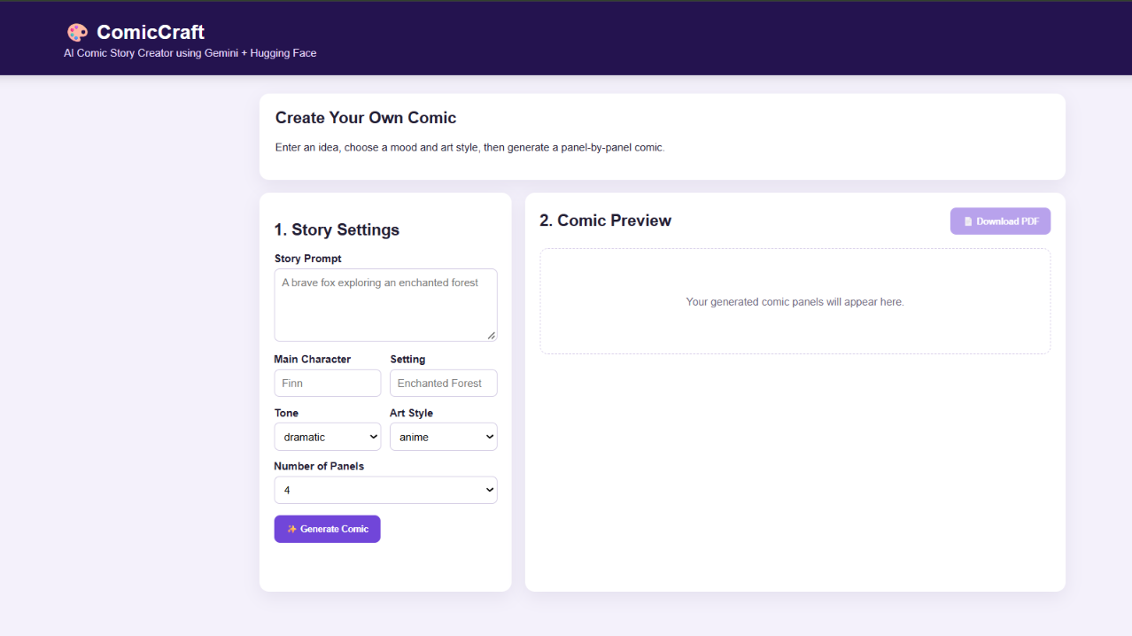

SAMPLE INPUT
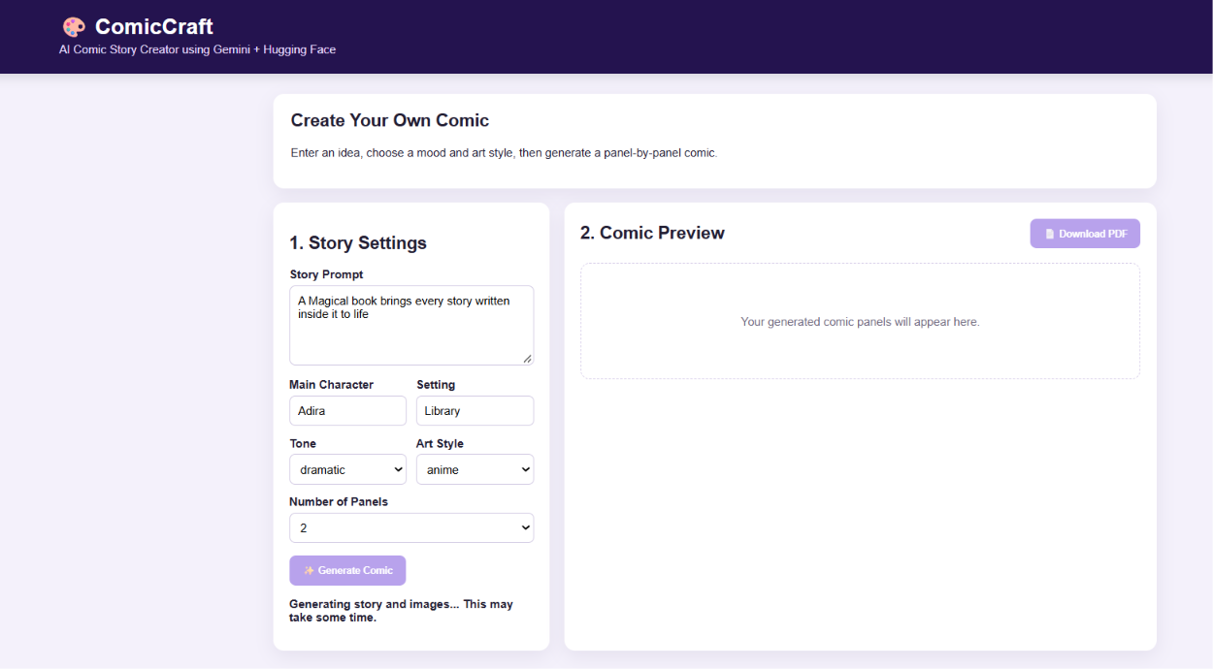

SAMPLE OUTPUT
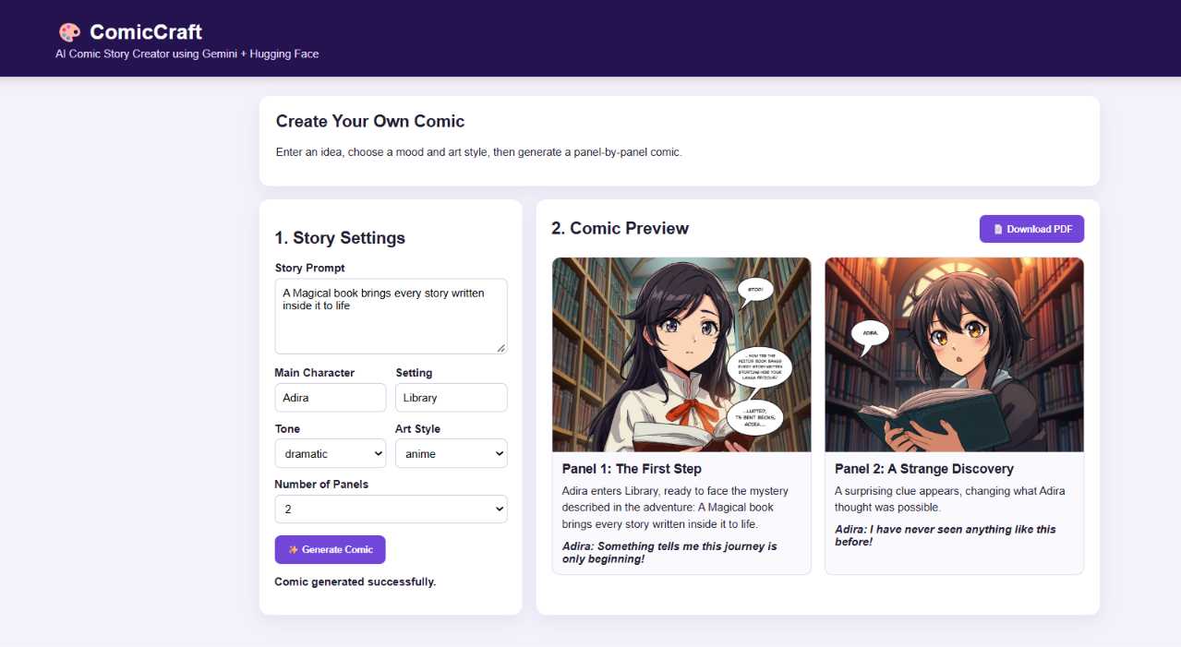

SAMPLE DOWNLOADED PDF
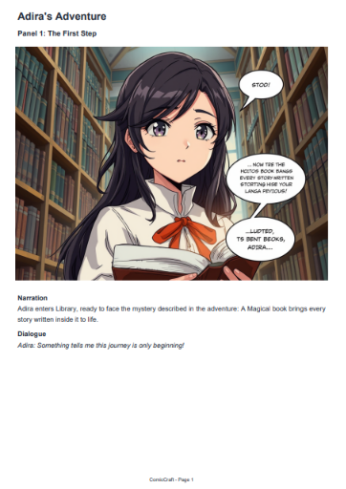
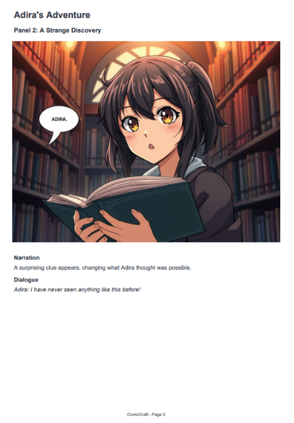

CONCLUSION & FUTURE DIRECTIONS

The ComicCraft solution completely meets operational goals established under the Naan Mudhalvan Skill Initiative blueprints. It proves that combining advanced Generative AI architectures with high-efficiency Python modern engines enables developers to construct fast, robust automation products. Future additions include linking automated artwork generation engines to produce visual assets inside script cards, alongside regional language support matrices.

